April 18, 2013

Dear Colleague:

It is my pleasure to invite you to attend the Administration for Children and Families (ACF), Region IV, Hispanic Healthy Marriage & Responsible Fatherhood Strengthening Families Forum: A Conversation: Connecting, Educating and Networking with Communities. This Forum is designed specifically for faith and community-based organizations, healthy marriage community coalitions, colleges and universities, healthy marriage and fatherhood grantees, public and private organizations, Head Start and Community Action Agencies, State and local human service agencies, and practitioners from various disciplines. This forum will be held on May 21-22, 2013 at the University of Miami Alumni Center, 6200 San Amaro Drive, Coral Gables, FL 33146.

The Hispanic Healthy Marriage Initiative and the Responsible Fatherhood Initiative promote culturally competent strategies for strengthening marriages, relationships, families and focusing on providing needed supports to assist fathers in connecting with their children. Research suggests that children raised in a married-couple household characterized by a healthy, loving relationship between two parents have, on average, better outcomes across a wide range of success indicators than children raised in single-parent households. It also indicates that both boys and girls benefit in many ways from the active involvement of their fathers in their lives.

The objective of the Forum is to explore emerging research on the Hispanic family experience, and to discuss the implications of the research for sustaining and strengthening Hispanic families, marriages and promoting responsible fatherhood. This event will also provide invitees with unique opportunities to exchange views and share information around critical issues affecting families and communities, focusing on healthy relationships and responsible fatherhood. A resource area will be provided that you can bring handouts for attendees to pick up.

I hope you will be able to join us, for your perspective will add a valuable dimension to this important discussion. Registration is free, but is required for all participants. We ask that you complete the enclosed Forum Registration Form and return it no later than Thursday, May 16, 2013, by e-mail to Koneta.perkins@acf.hhs.gov, or fax 404-562-2982. If you are not able to attend, please consider sending a representative. Should you have any questions please call Bridget Minor at 404-562-2903 or Koneta Perkins at 404-562-2956. I look forward to your participation.

Sincerely,
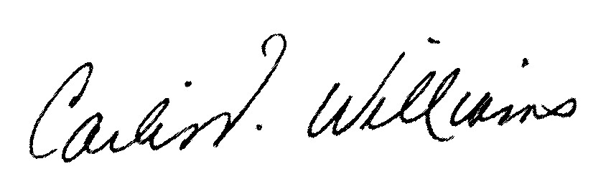

Carlis Williams

Southeast Regional Administrator
Administration for Children and Families

Registration Form

Hispanic Healthy Marriage &
Responsible Fatherhood Strengthening Families Forum
A Conversation: Connecting, Educating and Networking with Communities

May 21, 2013 8:30 am- 5:30 pm
May 22, 2013 8:30 am-12:45 pm

University of Miami Alumni Center
6200 San Amaro Drive
Coral Gables, FL 33146

No fee but registration is required Space is limited

Name:

Organization:

Phone Number:

Email: (please print clearly for confirmation)

Email registration to koneta.perkins@acf.hhs.gov OR Fax Form to: 404-562-2982

September 26-27, 2012
8:30 a.m. – 5:00 p.m.

